#include <iostream>
using namespace std;

int main() {

int num1, num2, sum;
// Input two numbers
cout << "Enter first number: ";
cin >> num1;
cout << "Enter second number: ";
cin >> num2;
// Calculate sum
sum = num1 + num2;
// Display result
cout << "The sum of " << num1 << " and " << num2 << " is: " << sum << endl;
return 0;
}
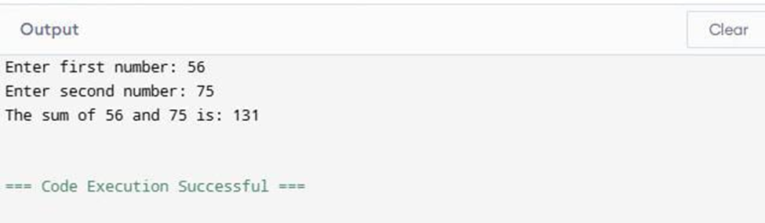

#include <iostream>
using namespace std;

int main() {
double principal, rate, time, simpleInterest;

// Input principal, rate, and time
cout << "Enter principal amount: ";
cin >> principal;
cout << "Enter rate of interest (in %): ";
cin >> rate;
cout << "Enter time (in years): ";
cin >> time;
// Calculate simple interest
simpleInterest = (principal * rate * time) / 100;
// Display result
cout << "Simple Interest is: " << simpleInterest << endl;
return 0;
}

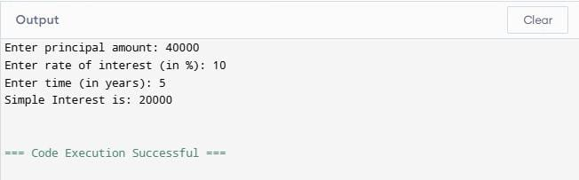

#include <iostream>
using namespace std;
int main() {
int num1, num2;
cout << "Enter two numbers: ";
cin >> num1 >> num2;

if (num1 > num2) {

cout << "The maximum number is: " << num1 << endl;
} else if (num2 > num1) {
cout << "The maximum number is: " << num2 << endl;
} else {
cout << "Both numbers are equal: " << num1 << endl;
}
return 0;
}

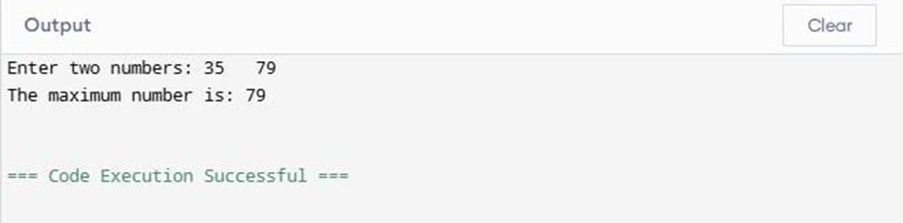

#include <iostream>
using namespace std;

int main() {
// Print numbers from 1 to 100
for (int i = 1; i <= 100; i++) {
cout << i << " ";
}
cout << endl;
return 0;
}
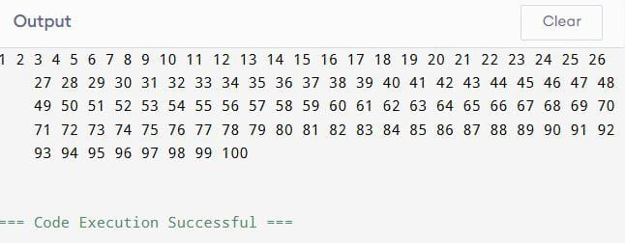

#include <iostream>
using namespace std;

int main() {
int n;
unsigned long long factorial = 1; // Use long long for large factorials
cout << "Enter a number: ";
cin >> n;
if (n < 0) {
cout << "Factorial is not defined for negative numbers." << endl;
}
else {
int i = 1;
while (i <= n) {
factorial *= i;
i++;
}
cout << "Factorial of " << n << " is: " << factorial << endl;
}
return 0;
}
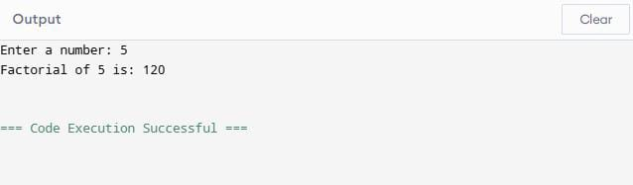

#include <iostream>
using namespace std;

int main() {
int num, reversed = 0;
cout << "Enter a number: ";
cin >> num;
int temp = num;
// Reverse the number using do-while loop
do {
int digit = temp % 10; // Get last digit
reversed = reversed * 10 + digit;
temp /= 10; // Remove last digit
} while (temp != 0);
cout << "Reversed number: " << reversed << endl;
return 0;
}
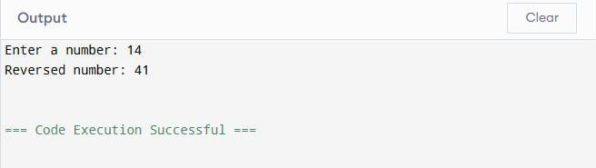

#include <iostream>
using namespace std;

int main() {
int num;
cout << "Enter a number: ";
cin >> num;
// Print multiplication table
for (int i = 1; i <= 10; i++) {
cout << num << " x " << i << " = " << num * i << endl;
}
return 0;
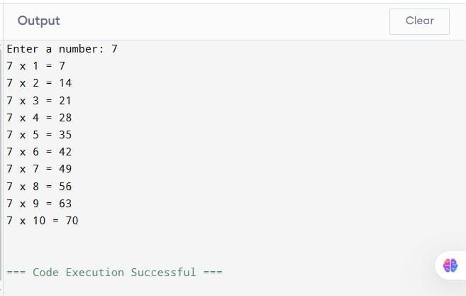
}

#include <iostream>
using namespace std;

int main() {

int sum = 0;

// Sum of even numbers from 1 to 100

for (int i = 2; i <= 100; i += 2) {
sum += i;
}
cout << "Sum of all even numbers between 1 and 100 is: " << sum << endl;
return 0;
}

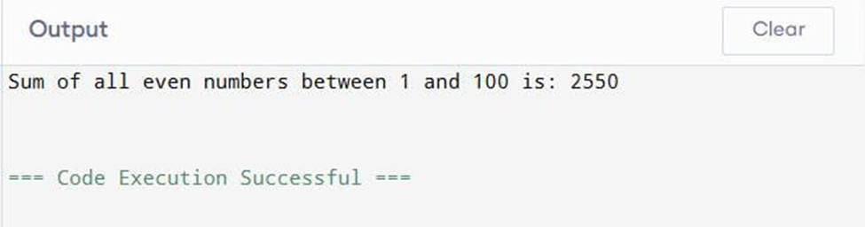

#include <iostream>
using namespace std;
int main() {
int n;
cout << "Enter number of elements: ";
cin >> n;
int arr[n];
// Input elements
cout << "Enter the elements of the array:\n";
for (int i = 0; i < n; i++) {
cin >> arr[i];
}
// Display elements
cout << "The elements in the array are:\n";
for (int i = 0; i < n; i++) {
cout << arr[i] << " ";
}
cout << endl;
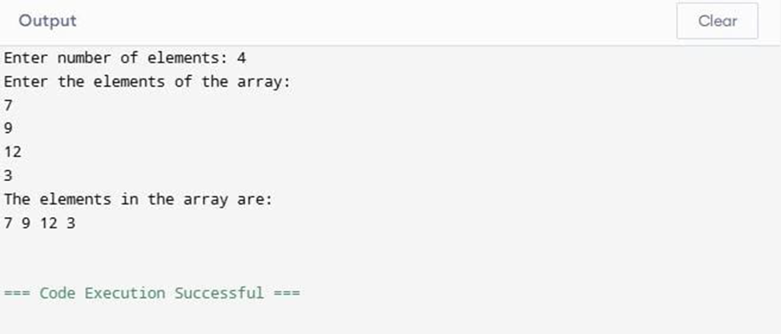
return 0;
}
#include <iostream>
using namespace std;
int main() {
int n;
cout << "Enter number of elements: ";
cin >> n;
int arr[n];
cout << "Enter the elements:\n";
for (int i = 0; i < n; i++) {
cin >> arr[i];}
int smallest = arr[0]; int largest = arr[0];
for (int i = 1; i < n; i++) {
if (arr[i] < smallest) {
smallest = arr[i];}
if (arr[i] > largest) {
largest = arr[i];}}
cout << "Smallest element: " << smallest << endl;
cout << "Largest element: " << largest << endl;
return 0;
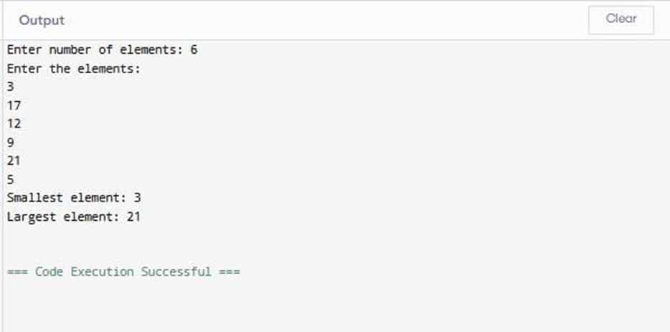
}
#include <iostream>
using namespace std;
int main() {
int rows, cols;
cout << "Enter number of rows: ";
cin >> rows;
cout << "Enter number of columns: ";
cin >> cols;
int arr[rows][cols];
cout << "Enter elements of the array:\n";
for (int i = 0; i < rows; i++) {
for (int j = 0; j < cols; j++) {
cin >> arr[i][j];}}
int sum = 0;
for (int i = 0; i < rows; i++) {
for (int j = 0; j < cols; j++) {
sum += arr[i][j];}}
cout << "Sum of all elements = " << sum << endl;
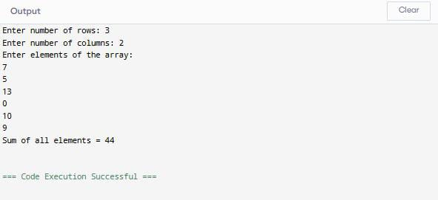
return 0;
}
#include <iostream>
using namespace std;
int main() {
int n;
cout << "Enter number of elements: ";
cin >> n;
int arr[n];
cout << "Enter elements of the array:\n";
for (int i = 0; i < n; i++) {
cin >> arr[i];}
// Reverse the array
for (int i = 0; i < n / 2; i++) {
int temp = arr[i];
arr[i] = arr[n - i - 1];
arr[n - i - 1] = temp;}
cout << "Reversed array:\n";
for (int i = 0; i < n; i++) {
cout << arr[i] << " ";}
return 0;
}
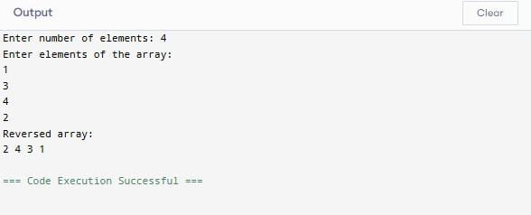
#include <iostream>
using namespace std;
int main() {
int n;
cout << "Enter number of elements: ";
cin >> n;
int arr[n];
cout << "Enter the elements:\n";
for (int i = 0; i < n; i++) {
cin >> arr[i];}
for (int i = 0; i < n - 1; i++) {
for (int j = 0; j < n - i - 1; j++) {
if (arr[j] > arr[j + 1]) {
int temp = arr[j];
arr[j] = arr[j + 1];
arr[j + 1] = temp;}}}
cout << "Sorted array in ascending order:\n";
for (int i = 0; i < n; i++) {
cout << arr[i] << " ";}
return 0;
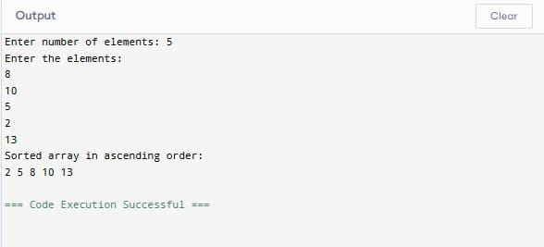
}
#include <iostream>
using namespace std;

struct Student {
string name;
int roll_no;
float marks;
};

int main() {
Student s;

// Input
cout << "Enter student name: ";
getline(cin, s.name);

cout << "Enter roll number: ";
cin >> s.roll_no;

cout << "Enter marks: ";
cin >> s.marks;

// Display
cout << "\n--- Student Details ---\n";
cout << "Name: " << s.name << endl;
cout << "Roll No: " << s.roll_no << endl;
cout << "Marks: " << s.marks << endl;

return 0;
}

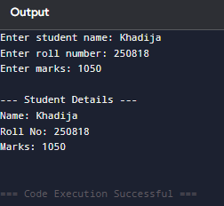

#include <iostream>
using namespace std;

struct Employee {
string name;
int id;
float salary;
};

int main() {
Employee emp[5];

// Input data for 5 employees
for (int i = 0; i < 5; i++) {
cout << "\nEnter details of employee " << i + 1 << ":\n";

cout << "Name: ";
cin.ignore(); // clear previous input
getline(cin, emp[i].name);

cout << "ID: ";
cin >> emp[i].id;

cout << "Salary: ";
cin >> emp[i].salary;
}

// Display data
cout << "\n\n--- Employee Information ---\n";
for (int i = 0; i < 5; i++) {
cout << "\nEmployee " << i + 1 << ":\n";
cout << "Name: " << emp[i].name << endl;
cout << "ID: " << emp[i].id << endl;
cout << "Salary: " << emp[i].salary << endl;
}
return 0;
}

#include <iostream>
using namespace std;

struct Student {
string name;
int rollNo;
float marks1, marks2, marks3; // 3 subjects
};

int main() {
Student s;
float average;

// Input
cout << "Enter student name: ";
getline(cin, s.name);

cout << "Enter roll number: ";
cin >> s.rollNo;

cout << "Enter marks of 3 subjects:\n";
cin >> s.marks1 >> s.marks2 >> s.marks3;

// Calculate average
average = (s.marks1 + s.marks2 + s.marks3) / 3;

// Output
cout << "\n--- Student Details ---\n";
cout << "Name: " << s.name << endl;
cout << "Roll No: " << s.rollNo << endl;
cout << "Average Marks: " << average << endl;

return 0;
}

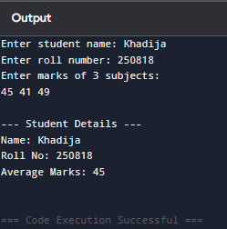

#include <iostream>
using namespace std;

struct Book {
string title;
string author;
float price;
};

int main() {
Book b;

// Input
cout << "Enter book title: ";
getline(cin, b.title);

cout << "Enter author name: ";
getline(cin, b.author);

cout << "Enter price: ";
cin >> b.price;

// Display
cout << "\n--- Book Information ---\n";
cout << "Title: " << b.title << endl;
cout << "Author: " << b.author << endl;
cout << "Price: " << b.price << endl;

return 0;
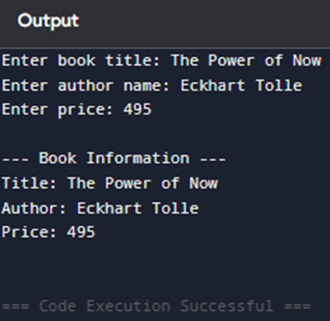
}

#include <iostream>
using namespace std;

struct Rectangle {
float length;
float width;
};

int main() {
Rectangle rect;
float area;

// Input
cout << "Enter length of the rectangle: ";
cin >> rect.length;

cout << "Enter width of the rectangle: ";
cin >> rect.width;

// Calculate area
area = rect.length * rect.width;

// Display
cout << "\nArea of the rectangle: " << area << endl;

return 0;
}
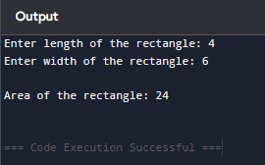

#include <iostream>
using namespace std;

// Function to calculate factorial
unsigned long long factorial(int n) {
unsigned long long fact = 1;
for (int i = 1; i <= n; i++) {
fact *= i;
}
return fact;
}

int main() {
int num;

cout << "Enter a number: ";
cin >> nu#include <iostream>
using namespace std;

// Function to calculate factorial
unsigned long long factorial(int n) {
unsigned long long fact = 1;
for (int i = 1; i <= n; i++) {
fact *= i;
}
return fact;
}

int main() {
int num;

cout << "Enter a number: ";
cin >> num;

if (num < 0) {
cout << "Factorial is not defined for negative numbers." << endl;
} else {
cout << "Factorial of " << num << " is: " << factorial(num) << endl;
}

return 0;
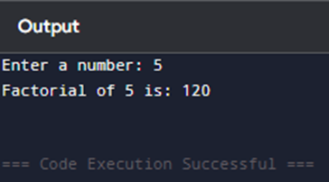
}

#include <iostream>
using namespace std;

// Function to swap two numbers
void swapNumbers(int &a, int &b) {
int temp = a;
a = b;
b = temp;
}

int main() {
int num1, num2;

cout << "Enter first number: ";
cin >> num1;

cout << "Enter second number: ";
cin >> num2;

cout << "\nBefore swapping: num1 = " << num1 << ", num2 = " << num2 << endl;

// Call the swap function
swapNumbers(num1, num2);

cout << "After swapping: num1 = " << num1 << ", num2 = " << num2 << endl;

return 0;
}

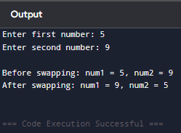

#include <iostream>
using namespace std;

// Function to check if a number is prime
bool isPrime(int n) {
if (n <= 1)
return false;
for (int i = 2; i * i <= n; i++) {
if (n % i == 0)
return false;
}
return true;
}

int main() {
int num;

cout << "Enter a number: ";
cin >> num;

if (isPrime(num))
cout << num << " is a prime number." << endl;
else
cout << num << " is not a prime number." << endl;

return 0;
}

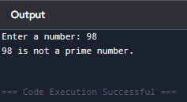
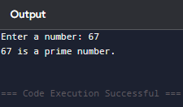

#include <iostream>
using namespace std;

// Recursive function to calculate power
double power(double base, int exponent) {
if (exponent == 0)
return 1; // base^0 = 1
else if (exponent > 0)
return base * power(base, exponent - 1);
else // for negative exponents
return 1 / power(base, -exponent);
}

int main() {
double base;
int exponent;

cout << "Enter base: ";
cin >> base;

cout << "Enter exponent: ";
cin >> exponent;

cout << base << " raised to the power " << exponent << " is: " << power(base, exponent) << endl;

return 0;
}

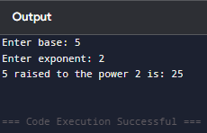
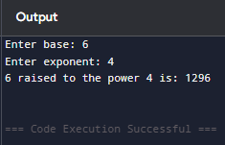

#include <iostream>
using namespace std;

// Function to find GCD using Euclidean algorithm
int gcd(int a, int b) {
while (b != 0) {
int temp = b;
b = a % b;
a = temp;
}
return a;
}

int main() {
int num1, num2;

cout << "Enter first number: ";
cin >> num1;

cout << "Enter second number: ";
cin >> num2;

cout << "GCD of " << num1 << " and " << num2 << " is: " << gcd(num1, num2) << endl;

return 0;
}

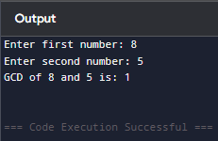

#include <iostream>
using namespace std;

int main() {
int n;

cout << "Enter the number of elements: ";
cin >> n;

int arr[n];
int *ptr = arr; // Pointer to the array

// Input elements using pointer
cout << "Enter " << n << " elements:\n";
for (int i = 0; i < n; i++) {
cin >> *(ptr + i);
}

// Display elements using pointer
cout << "\nThe elements of the array are:\n";
for (int i = 0; i < n; i++) {
cout << *(ptr + i) << " ";
}
cout << endl;

return 0;
}

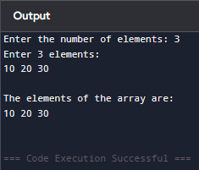

#include <iostream>
using namespace std;

int main() {
int n, sum = 0;

cout << "Enter the number of elements: ";
cin >> n;

int arr[n];
int *ptr = arr; // Pointer to the array

// Input elements using pointer
cout << "Enter " << n << " elements:\n";
for (int i = 0; i < n; i++) {
cin >> *(ptr + i);
}

// Calculate sum using pointer
for (int i = 0; i < n; i++) {
sum += *(ptr + i);
}

cout << "\nSum of all elements: " << sum << endl;

return 0;
}

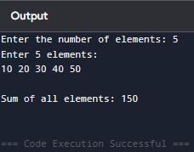

#include <iostream>
using namespace std;

int main() {
int n;
int* arr; // Pointer to hold dynamically allocated array

cout << "Enter the number of elements: ";
cin >> n;

// Dynamically allocate memory
arr = new int[n];

// Input elements
cout << "Enter " << n << " elements:\n";
for (int i = 0; i < n; i++) {
cin >> arr[i];
}

// Find the largest element
int largest = arr[0];
for (int i = 1; i < n; i++) {
if (arr[i] > largest) {
largest = arr[i];
}
}

cout << "The largest element is: " << largest << endl;

// Free the dynamically allocated memory
delete[] arr;

return 0;
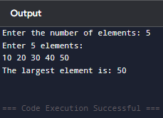
}

#include <iostream>
#include <cstring> // For strlen()
using namespace std;

int main() {
char str[100];

cout << "Enter a string: ";
cin.getline(str, 100); // To read string with spaces

char* start = str; // Pointer to the beginning
char* end = str + strlen(str) - 1; // Pointer to the last character
char temp;

// Reverse the string using pointers
while (start < end) {
// Swap characters
temp = *start;
*start = *end;
*end = temp;

// Move pointers
start++;
end--;
}

cout << "Reversed string: " << str << endl;

return 0;
}

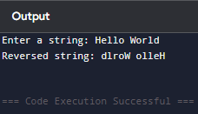
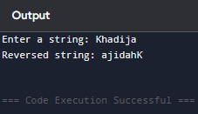
}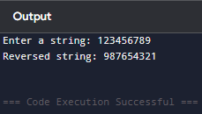

#include <iostream>
using namespace std;

class Rectangle {
private:
double length;
double width;

public:
// Function to set length and width
void setDimensions(double l, double w) {
length = l;
width = w;
}

// Function to calculate area
double area() {
return length * width;
}

// Function to calculate perimeter
double perimeter() {
return 2 * (length + width);
}
};

int main() {
Rectangle rect;
double l, w;

cout << "Enter length of rectangle: ";
cin >> l;
cout << "Enter width of rectangle: ";
cin >> w;

rect.setDimensions(l, w);

cout << "Area of rectangle: " << rect.area() << endl;
cout << "Perimeter of rectangle: " << rect.perimeter() << endl;

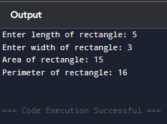
return 0;
}

#include <iostream>
using namespace std;

const double PI = 3.14159;

class Circle {
private:
double radius;

public:
// Function to set the radius
void setRadius(double r) {
radius = r;
}

// Function to calculate area
double area() {
return PI * radius * radius;
}

// Function to calculate circumference
double circumference() {
return 2 * PI * radius;
}
};

int main() {
Circle c;
double r;

cout << "Enter radius of the circle: ";
cin >> r;

c.setRadius(r);

cout << "Area of the circle: " << c.area() << endl;
cout << "Circumference of the circle: " << c.circumference() << endl;

return 0;
}

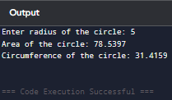

#include <iostream>
#include <string>
using namespace std;

class Student {
private:
string name;
int rollNo;
float marks;

public:
// Constructor to initialize student details
Student(string n, int r, float m) {
name = n;
rollNo = r;
marks = m;
}

// Function to display student information
void display() {
cout << "Student Name: " << name << endl;
cout << "Roll Number: " << rollNo << endl;
cout << "Marks: " << marks << endl;
}
};

int main() {
string name;
int roll;
float marks;

// Input student details
cout << "Enter student name: ";
getline(cin, name);
cout << "Enter roll number: ";
cin >> roll;
cout << "Enter marks: ";
cin >> marks;

// Create Student object using constructor
Student s(name, roll, marks);

// Display student information
cout << "\nStudent Information:\n";
s.display();

return 0;
}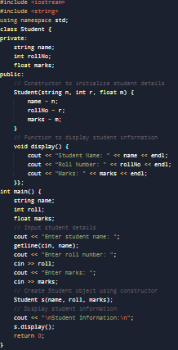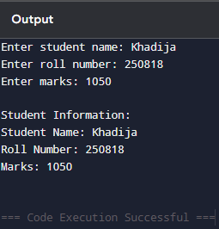#include <iostream>
#include <string>
using namespace std;

class Employee {
private:
string name;
int id;
double salary;

public:
// Function to input employee details
void inputDetails() {
cout << "Enter employee name: ";
getline(cin, name);
cout << "Enter employee ID: ";
cin >> id;
cout << "Enter employee salary: ";
cin >> salary;
cin.ignore(); // To clear the newline character from input buffer
}

// Function to display employee details
void displayDetails() {
cout << "\nEmployee Information:\n";
cout << "Name: " << name << endl;
cout << "ID: " << id << endl;
cout << "Salary: " << salary << endl;
}
};

int main() {
Employee emp;

// Input and display employee details
emp.inputDetails();
emp.displayDetails();

return 0;
}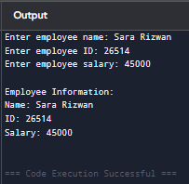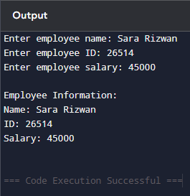#include <iostream>
#include <string>
using namespace std;

// Base class
class Person {
protected:
string name;
int age;

public:
void setPersonDetails(string n, int a) {
name = n;
age = a;
}

void displayPersonDetails() {
cout << "Name: " << name << endl;
cout << "Age: " << age << endl;
}
};

// Derived class
class Student : public Person {
private:
int rollNo;
float marks;

public:
void setStudentDetails(int r, float m) {
rollNo = r;
marks = m;
}

void displayStudentDetails() {
displayPersonDetails(); // Display base class details
cout << "Roll Number: " << rollNo << endl;
cout << "Marks: " << marks << endl;
}
};

int main() {
Student s;
string name;
int age, roll;
float marks;

// Input person details
cout << "Enter name: ";
getline(cin, name);
cout << "Enter age: ";
cin >> age;

// Input student details
cout << "Enter roll number: ";
cin >> roll;
cout << "Enter marks: ";
cin >> marks;

// Set details using member functions
s.setPersonDetails(name, age);
s.setStudentDetails(roll, marks);

// Display student information
cout << "\nStudent Information:\n";
s.displayStudentDetails();

return 0; 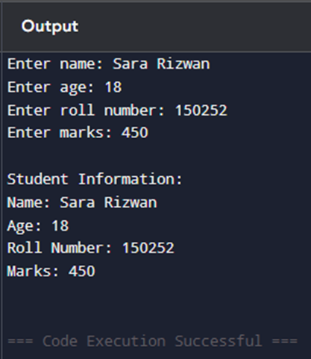#include <iostream>
#include <string>
using namespace std;

// Base class
class Animal {
protected:
string species;

public:
void setAnimalDetails(string s) {
species = s;
}

void displayAnimalDetails() {
cout << "Species: " << species << endl;
}
};

// Derived class from Animal
class Mammal : public Animal {
protected:
string habitat;

public:
void setMammalDetails(string h) {
habitat = h;
}
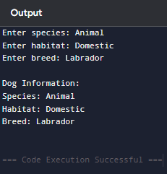
void displayMammalDetails() {
displayAnimalDetails(); // Display base class details
cout << "Habitat: " << habitat << endl;
}
};

// Derived class from Mammal
class Dog : public Mammal {
private:
string breed;

public:
void setDogDetails(string b) {
breed = b;
}

void displayDogDetails() {
displayMammalDetails(); // Display base and intermediate class details
cout << "Breed: " << breed << endl;
}
};

int main() {
Dog d;
string species, habitat, breed;

// Input details
cout << "Enter species: ";
getline(cin, species);
cout << "Enter habitat: ";
getline(cin, habitat);
cout << "Enter breed: ";
getline(cin, breed);

// Set details
d.setAnimalDetails(species);
d.setMammalDetails(habitat);
d.setDogDetails(breed);

// Display dog details
cout << "\nDog Information:\n";
d.displayDogDetails();

return 0;
}
}#include <iostream>
#include <string>
using namespace std;

// Base class 1
class Teacher {
protected:
string subject;

public:
void setTeacherDetails(string sub) {
subject = sub;
}

void displayTeacherDetails() {
cout << "Subject taught: " << subject << endl;
}
};

// Base class 2
class Researcher {
protected:
string field;

public:
void setResearcherDetails(string f) {
field = f;
}

void displayResearcherDetails() {
cout << "Research field: " << field << endl;
}
};

// Derived class using multiple inheritance
class Professor : public Teacher, public Researcher {
private:
string name;
int age;

public:
void setProfessorDetails(string n, int a) {
name = n;
age = a;
}

void displayProfessorDetails() {
cout << "Professor Name: " << name << endl;
cout << "Age: " << age << endl;
displayTeacherDetails(); // From Teacher class
displayResearcherDetails(); // From Researcher class
}
};

int main() {
Professor p;
string name, subject, field;
int age;

// Input professor details
cout << "Enter professor name: ";
getline(cin, name);
cout << "Enter age: ";
cin >> age;
cin.ignore(); // Clear input buffer
cout << "Enter subject taught: ";
getline(cin, subject);
cout << "Enter research field: ";
getline(cin, field);

// Set details
p.setProfessorDetails(name, age);
p.setTeacherDetails(subject);
p.setResearcherDetails(field);

// Display professor details
cout << "\nProfessor Information:\n";
p.displayProfessorDetails();

return 0;
}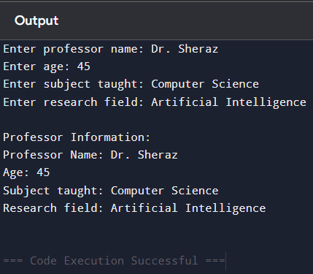#include <iostream>
#include <fstream>
#include <string>
using namespace std;

int main() {
string filename = "data.txt"; // Name of the file
string data;

// Open file in append mode
ofstream outfile;
outfile.open(filename, ios::app); // ios::app ensures data is added at the end

if (!outfile) {
cout << "Error opening file!" << endl;
return 1;
}

cout << "Enter data to append: ";
getline(cin, data);

// Write data to file
outfile << data << endl;

cout << "Data appended successfully." << endl;

outfile.close(); // Close the file
return 0;
}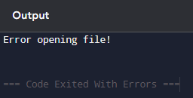#include <iostream>
using namespace std;

// Base class
class A {
public:
A() {
cout << "Constructor of Class A (Base Class)" << endl;
}
};

// Derived class from A
class B : public A {
public:
B() {
cout << "Constructor of Class B (Derived Class)" << endl;
}
};

// Further derived class from B
class C : public B {
public:
C() {
cout << "Constructor of Class C (Further Derived Class)" << endl;
}
};

int main() {
cout << "Creating object of class C:\n";
C obj; // Only one object of the most derived class

return 0;
}